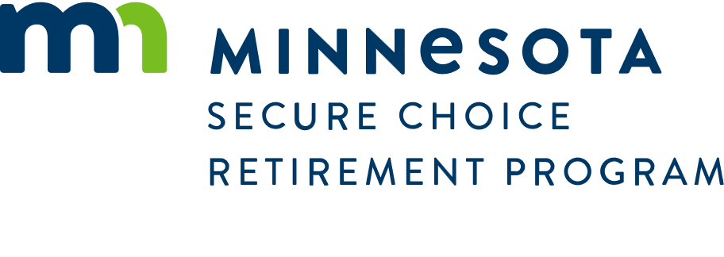

March 31, 2025

## NOTICE TO REQUEST PROPOSALS TO ENTER INTO A JOINT POWERS AGREEMENT TO JOIN A PARTNERSHIP WITH ANOTHER STATE OFFERING AN AUTO-IRA PROGRAM

The Minnesota Secure Choice Board is soliciting proposal to join a partnership with an existing state offering a similar Auto-IRA Program. The partnership would be accomplished by entering into a Joint Powers Agreement with Minnesota.

All interested states should contact the person named below by email to request a copy of the Request to enter into a Joint Powers Agreement.

David Bergstrom

Interim Executive Director

Minnesota Secure Choice Retirement Program

520 Lafayette Rd. 2nd Floor

St. Paul, MN 55155

[David.Bergstrom@state.mn.us](mailto:David.Bergstrom@state.mn.us)

* **All proposals are due electronically (emailed) no later than 3:00 p.m. Central Time on May 16, 2025.**
* **Early submission is encouraged.**
* **No proposals received after that date and time will be considered**.